Outlook Web Access (Email)

Arlington Public Schools uses the Microsoft Office 365 Exchange Online email platform. You can access your email mailbox by following the instructions below.

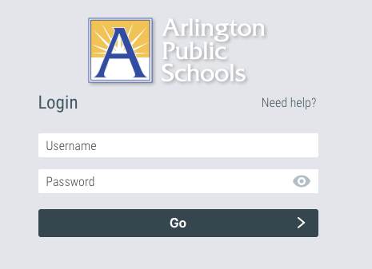
.

- Log into MyAccess
- You can access MyAccess by clicking on the MyAccess icon located on your desktop.
- You can also access MyAccess by opening your browser and typing in the following address: myaccess.apsva.us
- On the MyAccess login screen, enter your student ID and password and click Go.


- Open Outlook on the web (accessing your mailbox)
- Once logged into MyAccess, locate and click on the “Outlook Web Access” icon. Clicking on the Outlook Web Access icon will open your email mailbox and place you in the inbox of your email account.

General Outlook Tips

Sending, Receiving, and Forwarding Emails
Visit this link to learn how to create, reply to, and forward email messages in Outlook on the web.

Email Account Folders
By default, your account starts with these folders:
- Inbox Incoming messages arrive in your inbox unless you’ve created an Inbox rule to redirect them to another folder, or they’re identified as junk email.

- Junk Email Messages that have junk email characteristics but that aren’t blocked by a spam filter before they reach your mailbox will automatically be moved to this folder. Learn more about how to Filter junk email and spam in Outlook on the web.

- Drafts If you start writing a message but don't finish, it will automatically be saved to your Drafts folder. You can come back to the message later to continue editing it, and then send it.

- Sent Items By default, a copy of every message you send is put in your Sent Items folder.

- Deleted Items When you delete a message, it’s moved to the Deleted Items folder.

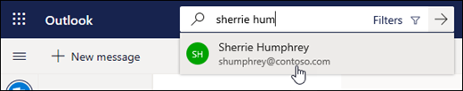
Searching for A Message
- In the Search box in Mail, type what you want to search for (a contact, subject, part of a message, or name of a file) and press Enter.


- When you're done with the search, select Exit Search in the Search box or choose any folder in the navigation pane to exit the search.

